# Linux Practical

1. **Manipulating Files and Directories**

We can create, delete, copy or move any file or directory using below command:

* 1. **mkdir:** We can create any directory using **‘mkdir’** command.

***Syntax:*** *mkdir `folder_name`*

* 1. **touch:** We can create any file using **‘touch’** command.

***Syntax:*** *touch `file_name`*

**For example:**

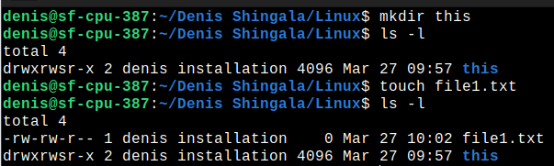

* 1. **cp:** We can copy any file and past it anywhere using **‘cp’** command.

***Syntax:*** *cp ‘target_file’ ‘directory_name’*

* 1. **mv:** We can cut any file or folder and past it anywhere using **‘mv’** command.

***Syntax:*** *mv `target_file’ ‘directory_file’*

**Note:** When you are working with **folder or directory** that time some time it’s throw an error that **‘Directory is not empty’** so that time you have to add **‘r’** option in both **‘cp’ and ‘mv’** command. It will do whole operation recursively.

**For example:**

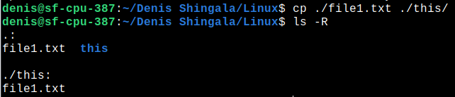

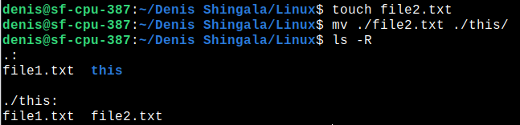

* 1. **rmdir:** We can delete directory using **‘rmdir’** command.
  2. **rm:** We can delete file or folder using **‘rm’** command. when we used this command to remove directory that time we havr to add **‘r’** flag for recursively work.

**For example:**

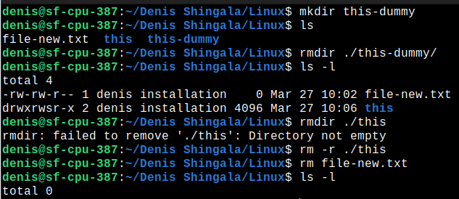

1. **List all file permissions with example**

If you want to see permission of any file in current directory that time you have to use **‘l’** flag in **ls** command.

In below example ‘**this’** folder’s first column is ‘drwxrwsr-x**’.** It is a permission of that file to user.

Here, First let is show that, is it folder or directory? here, ‘d’ stand for directory.

after that first 3 letter use for user, after that 3 letter use for group and remaining are use for other user.

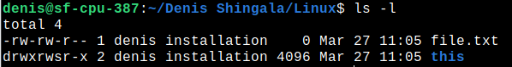

1. **List all running process**

The ps command allows you to display information about running processes.

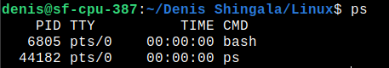

Here, it will show static data but if you want to see dynamic data then use **‘top’**

command for see the all processes of cpu.

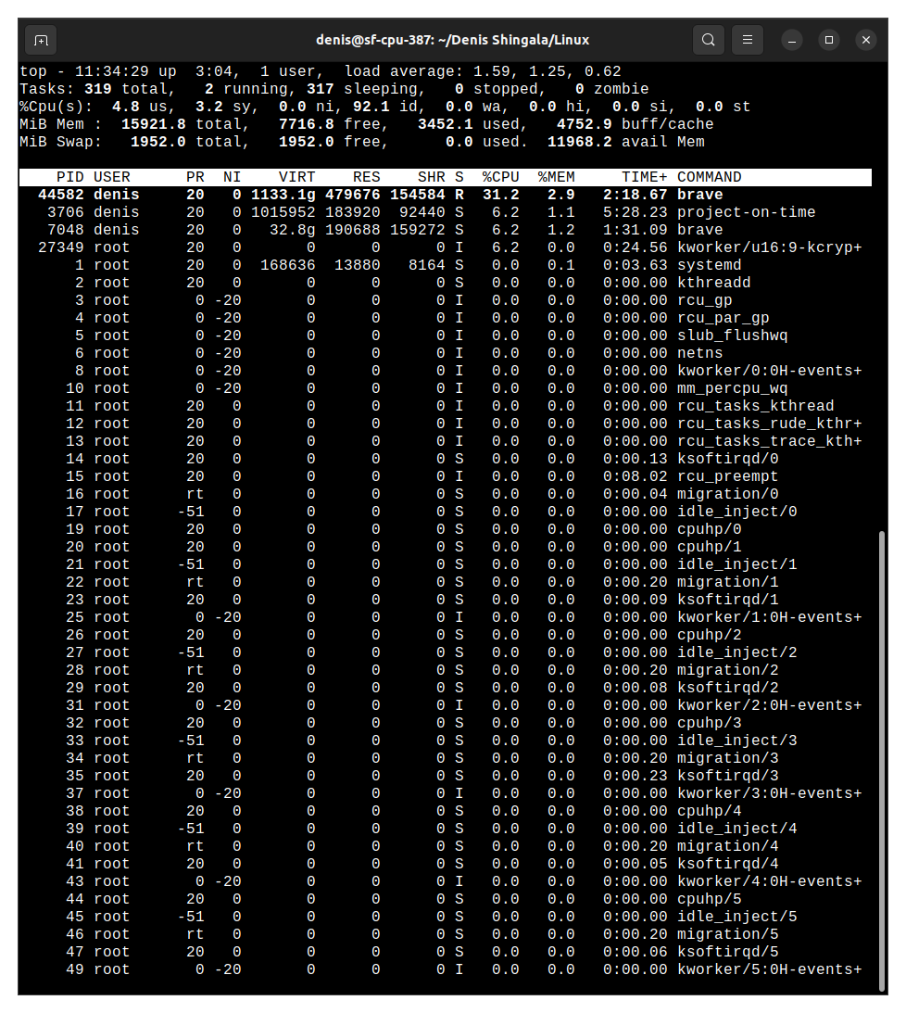

1. **Find particular process by it’s name**

You can find the particular process by it’s name using **‘pidof’** command.It will

return all pid(Process id) of that process.

Now, if you want to show it inside all process which is running inside CPU so that you can add filter inside **‘top’** command using **’grep’** command.

**For example,**

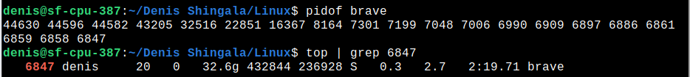

1. **How to kill any particular process**

We can kill any process via terminal using **‘kill’** command.

Here, is example of kill command. so first of all we have to find the pid of particular process then kill it using kill command.

**For example,**



1. **Vi or Vim for file editing**

If we want to read or update file then Vim is best tool to manipule file.

We can open file in Vim editor using **‘vim’** command.

Here, is a example of vim editor. when you enter inside the vim editor you have to press ‘I’ for insert mode and write whatever you want.

vim

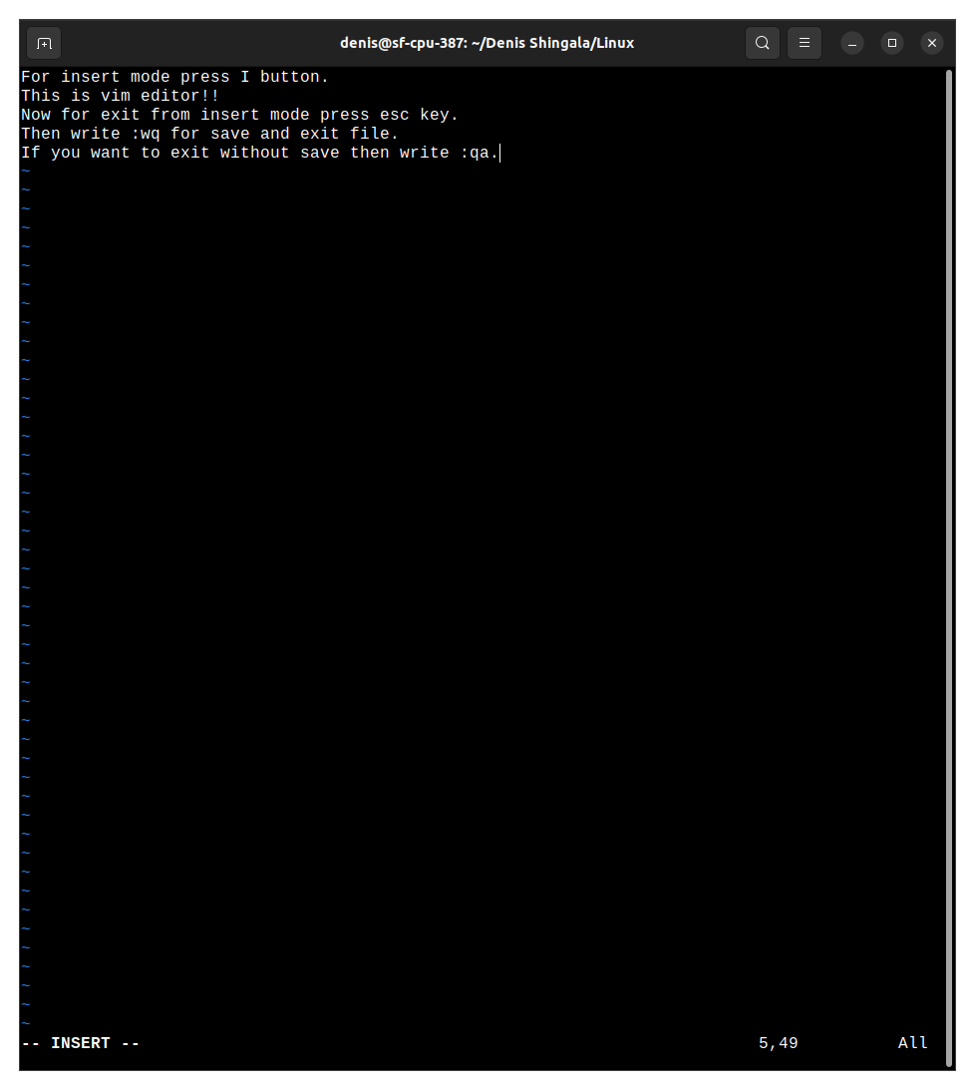

1. **Change file owner and group**

If you want to change the permission of file then use **‘chmod’** command.

Here, is a one file if we want change it’s user permission that user should be only read that file then we have use **‘chmod u-wx+r {file/directory name}’.**

***Syntax:*** *chmod {person -/+ permission} {file name}*

*here, person might be u(user)/ o(other)/ a(all)/ g(group) and ‘r’ stand for read, ‘w’ stand for write, ‘x’ stand for executable.*

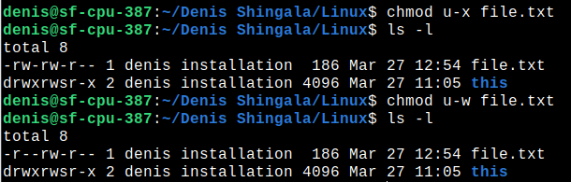

If you want to change the file owner and group then use **‘chown’** command in linux.

Note: For that we have to give administrator level permission.

**For example,**

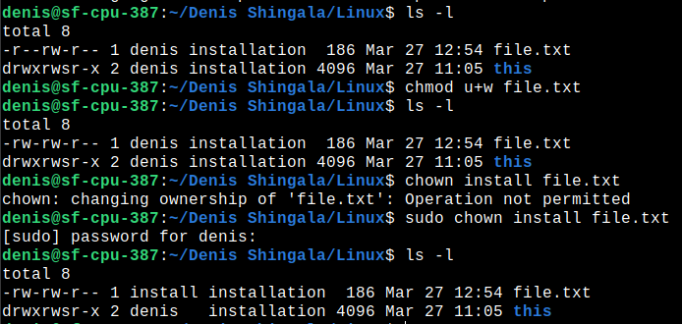

1. **Change group ownership**

We can change it using **‘chown’** command but we have to write group name after ‘:’ we will see it via example.

***Syntax:*** *chown {user : group} {file name}*

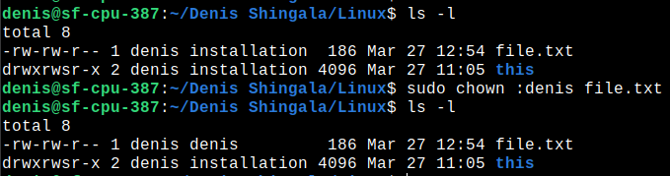

1. **Moving and Renaming Files**

We can cut any file or folder and past it anywhere using **‘mv’** command.

***Syntax:*** *mv `target_file’ ‘directory_file’*

**Note:** When you are working with **folder or directory** that time some time it’s throw an error that **‘Directory is not empty’** so that time you have to add **‘r’** option in both **‘cp’ and ‘mv’** command. It will do whole operation recursively.

**For example:**

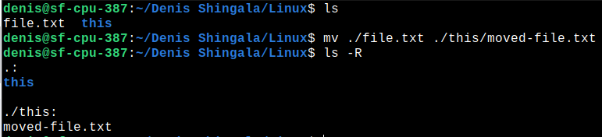

1. **Remove Files and Directories**

We can rename any file or directory using **‘mv’** command.

Here, is a example of that.



1. **List the directory contents**

If we want to show the all details of current directory’s file then we can see it using **‘ls’** command.

***Syntax:*** *ls {option} {directory name}*

There many flag in ls command below you can see.

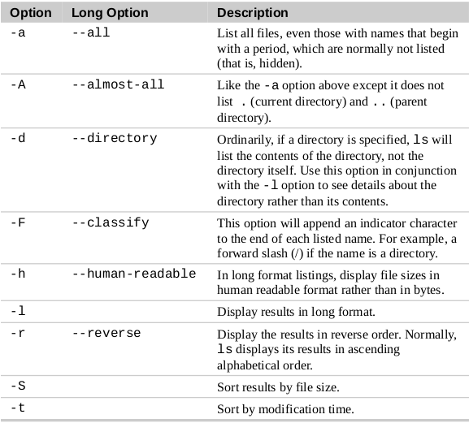

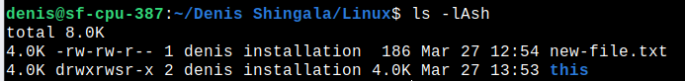

1. **How I can get the path of working directory**

We can see it using **‘pwd’** command.

pwd

1. **How to Search in Vim/Vi**

If we want to search some pattern inside the file using vim editor then use below syntax:

/{target pattern}

**For example:**

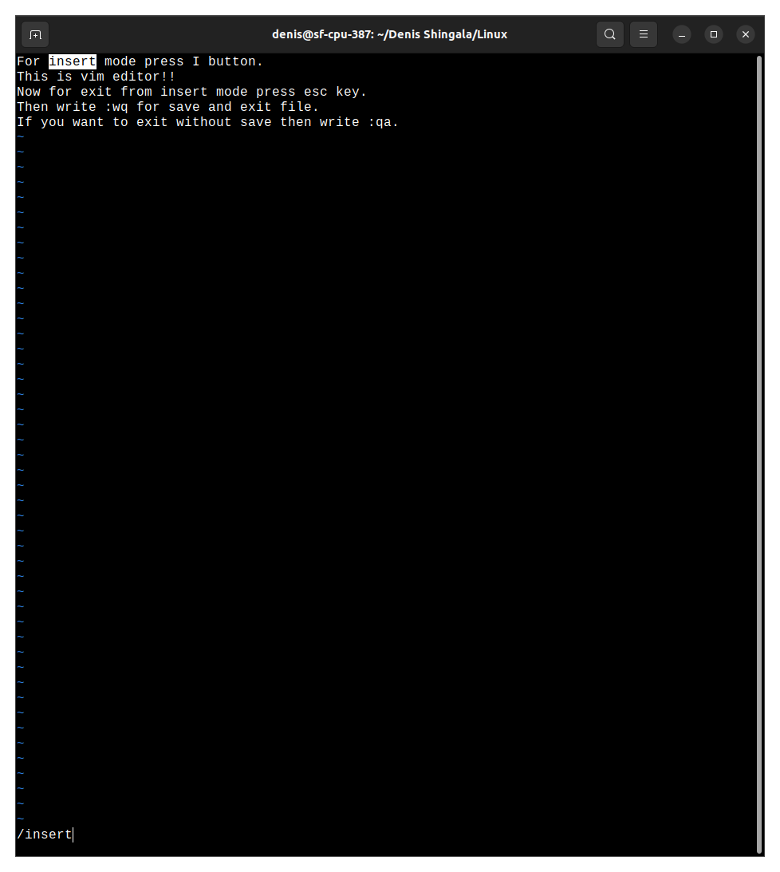

Note: If you want to search same pattern in whole document then press enter and then press n key it will search it in whole document.

1. **How do you do a search and replace in Vim/Vi**

If we want to replace some pattern inside the file using vim editor then use below syntax:

:%s/{target-pattern}/{new-pattern}

here, % for whole document if you want to replace specific line then bring your cursor at that line and use below syntax:

:s/{target-pattern}/{new-pattern}

Press Enter!!

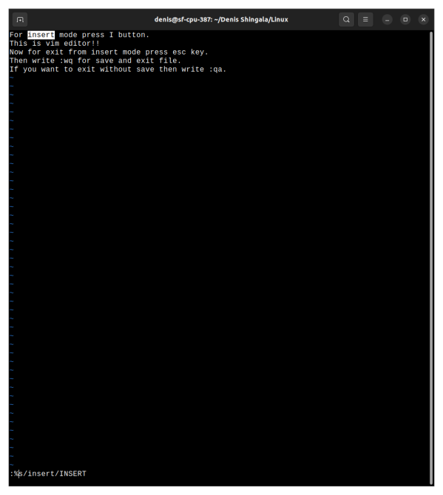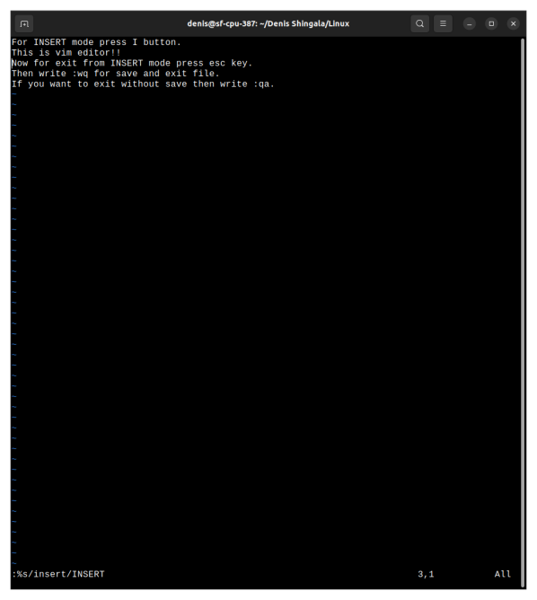**For example,**

1. **How we can save and exit from Vim/Vi file**

If we want to exit with save current changes then use ‘**esc’** key and write **‘:wq’** for save and exit from vim editor.

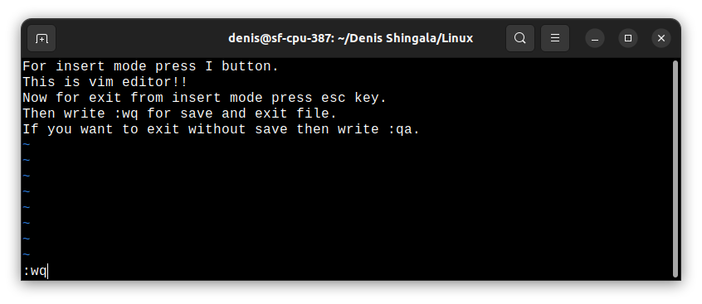

exit